# Unit 4 Assignment: Overview

# Amon-ra

# Herzing University

BU 630-7A Project and Operations Management

**Introduction**:

InterTech is a technology company specializing in managed and support services. The company provides the service of managing and supporting the I.T. infrastructure of small-size and medium companies. Such companies usually have a small information technology team or department. The scope of work of such teams are usually limited due to their small size. Such inefficiencies places limitations on the internal staff. InterTech helps to fill-in were those teams fall short with our certified staff of professions. Our staff covers the entire spectrum of the information technology industry.

InterTech managed services offering consists of creating an information technology infrastructure and solution based on the requirements of the business. Out team will design, configure and support the solution. Support service provides hardware coverage for company when things don’t work as expected. Access issues, circuit outages, performances issue, InterTech has 24x7 support engineers ready to act when customer equipment doesn’t function as it should.

The nature of the Information Technology Industry is a state of constant flux with new technology being created and present technology evolving. InterTech must also evolve with industry trends. In an effort to expand company operations, InterTech has partnered with Cisco, a worldwide IT, networking, and cybersecurity solutions giant, in the software defined network (SDN) space.

One SDN solution offered is Viptela SD-WAN offered by Cisco. Cisco purchased the company in 2017 for $610 million dollars. The SD-WAN stands for Software Defined Wide Area Network. Viptela SD-WAN is a cloud-incorporated solution applied in the context of wide area networks (WAN). The cloud is having a game-changing effect on business and the technology infrastructure. InterTech believes that it can position itself at the front of technology through this partnership. Cisco has the hardware and InterTech can provide the support for the technology. Partnering with Cisco allows our company to be a value-added reseller (VARs) and places our company in a strategic position to work with the biggest company in the network sector of information technology industry.

**Project** **Leader**: Amon-ra **Company** InterTech **Role**: Project Manager

**Project** **Title**: SD-WAN Support

**Situation:**

How to remain relevant in the most rapid changing industry and provide our customers the leadership they require through the use of cloud technology.

**Project** **Rationale**:

“Cloud adoption has seen a significant increase over the last few years and recent reports from Gartner suggest that we will see a 50 per cent investment in cloud technology over the next four years.” (O’Neal, 2018) The cloud can be traced back to mainframe computing and was expanded with the invention of the Advanced Research Projects Agency Network (ARPANET) in 1960s. ARPANET broke geographical boundaries and allowed connections in physically different locations. From this, virtual private network (VPN) became possible, allowing devices in different geographical locations to appear to be on the same local network. In 1996, in the offices of Compaq, the term, “cloud computing”, is used for the first time. In very basic terms, cloud computing can be traced to earlier forms of technology that contributed to its beginning, but true cloud computing did not take place until the advent of Salesforce.com in 1999.

Salesforces was a major milestone for cloud computing, demonstrating the possibilities and made the idea of additional advancements possible. Amazon Web Services, Microsoft Azure, Google Cloud, Office 365, Gmail, Alibaba Cloud, Dropbox, Cloud has developed and grown over the years with additional advancement projected for the future. More businesses are embracing the cloud, implementing it into their infrastructure and migrating parts of their business to the cloud.

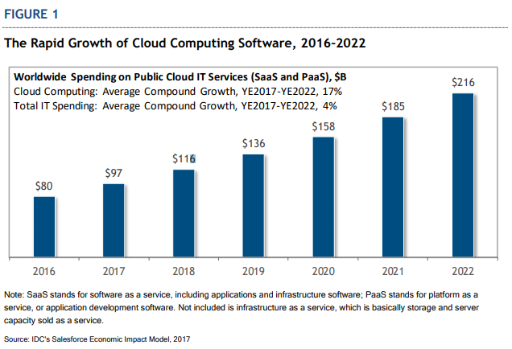

Note Reprinted from The Salesforce Economy Forecast: 3.3 Million New Jobs and $859 Billion New Business Revenue to Be Created from 2016 to 2022, by John F. Gantz. Retrieved from <https://www.salesforce.com/content/dam/web/en_us/www/documents/white-papers/idc-study-salesforce-economy.pdf> Copyright 2017 by IDC

**Assessment**:

For InterTech, the cloud, presents a threat that can become an opportunity.

* + **The Threat:** If the company fails to embrace this technological shift and offer a cloud solution to present and potential customers, those customers may acquire such services from our competitors. The reality is that the cloud is here and it is growing.
  + **The Opportunity**: The company must adapt to this change and harness the capabilities of this technology to advance the company’s offerings whereby it may in turn advance our customer’s technology. This will align us with the technology and give us the cutting-edge required of a business in the technology realm.

SD-WAN offers the following benefits to for customers:

* + Cost savings through the elimination of more costly WAN solution such as MPLS
  + Improved performance – Many of the power intensive processes of the control plane are decoupled from the actual device and placed in a cloud environment. This frees the device of those processes and allows that computing power to be used in other ways to add to the efficiency of the device.
  + Ease of manageability – Management of the SD-WAN devices take place in the cloud dashboard. All devices can be accessed from the dashboard after authenticating access credentials once, as opposed to the traditional WAN method of inefficiently logging into each device separately using access credentials each time.

|  |  |  |
| --- | --- | --- |
| **TASK** | **ASSIGNED TO** | **TIME (days)** |
| Submit a network design ticket | Design Team | 1 |
| Assessment of current WAN router | Design Team | 5 |
| Design Team submits change ticket | Design Team | 1 |
| Set maintenance window | Install Team | 1 |
| Backup config of current router | Install Team | 1 |
| Copy config to Viptela replacement | Install Team | 3 |
| Decommission current router | Install Team | 1 |
| Install Viptela Router | Install Team | 1 |
| Test | Install Team | 1 |
| Handoff to Operations Team | Install Team | 1 |

Upon the Install Team completing and validating the functionality of Viptela SD-WAN device, the migration project will be complete and the site will now be marked as being upgrade to Viptela SDWAN. At this point the InterTech Team will provide the deliverables

**Deliverables**

1. Account Manager
2. Device(s) location
3. Trouble Ticket Submission

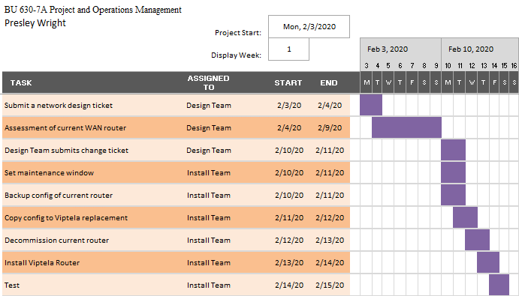

**Critical Path**

Submit Network Design Ticket

Time 1 days

Assessment of current WAN router

Time 5 days

Design Team submits Change ticket

Time 1 days

Set Maintenance Window

Time 1 days

Backup config of current router

Time 1 days

Copy configuration to Viptela replacement

Time 3 days

Decommission the current router

Time 1 days

Install Viptela Router

Time 1 days

Test

Time 1 days

Handoff to Ops Team

Time 1 days

References

## Cerf, V. G., Clark, D. D., Kahn, R. E., Kleinrock, L. C., Leiner, B., Lynch, D. G., … Wolff, S. (1997). Brief History of the Internet. Retrieved from https://www.internetsociety.org/internet/history-internet/brief-history-internet/

## Cooney, Michael. "Cisco grabs-up SD-WAN player Viptela for $610M." Network World, 1 May 2017. Gale OneFile: Computer Science, https://link.gale.com/apps/doc/A490995821/CDB?u=lirn50909&sid=CDB&xid=25bbfa8f. Accessed 1 Feb. 2020.

## Gantz, J. F. (2017, October). The Salesforce Economy Forecast: 3.3 Million New Jobs and $859 Billion New Business Revenue to Be Created from 2016 to 2022. Retrieved from https://www.salesforce.com/content/dam/web/en_us/www/documents/white-papers/idc-study-salesforce-economy.pdf

## Goddard, W. (2020, January 29). The Evolution of Cloud Computing – Where's It Going Next? Retrieved from https://itchronicles.com/cloud/the-evolution-of-cloud-computing-wheres-it-going-next/

## Linthicum, David. "Cloud spending set to outpace traditional computing." InfoWorld.com, 21 Jan. 2020, p. NA. Gale OneFile: Computer Science, https://link.gale.com/apps/doc/A611840481/CDB?u=lirn50909&sid=CDB&xid=47867b5a. Accessed 1 Feb. 2020.

## O’Neal, T. (2018, December 21). The future of cloud computing in 2019. Retrieved from https://www.techradar.com/news/the-future-of-cloud-computing-in-2019

## Regalado, A. (2013, December 30). Who Coined 'Cloud Computing'? Retrieved from https://www.technologyreview.com/s/425970/who-coined-cloud-computing/

## https://www.cisco.com/c/dam/en_us/about/ac49/ac20/downloads/annualreport/ar2008/pdf/cisco_ar2008_corporate_information.pdf. (n.d.). Retrieved January 31, 2020, from https://www.cisco.com/c/dam/en_us/about/ac49/ac20/downloads/annualreport/ar2008/pdf/cisco_ar2008_corporate_information.pdf

## What Is SD-WAN? - Software-Defined WAN (SD-WAN). (2019, December 23). Retrieved from https://www.cisco.com/c/en_in/solutions/enterprise-networks/sd-wan/what-is-sd-wan.html

## Williams, H. (2018, March 13). The history of cloud computing: A timeline of key moments from the 1960s to now. Retrieved from https://www.computerworld.com/article/3412271/the-history-of-cloud-computing--a-timeline-of-key-moments-from-the-1960s-to-now.html#slide4